**Title:** Task B-1 Report

**Author:** Robin Findlay-Marks, s103603871

**Setup Attempt:**

The setting up of v0.1 went smoothly, after I installed all the requirements, the python file ran well as can be seen in Figure 01

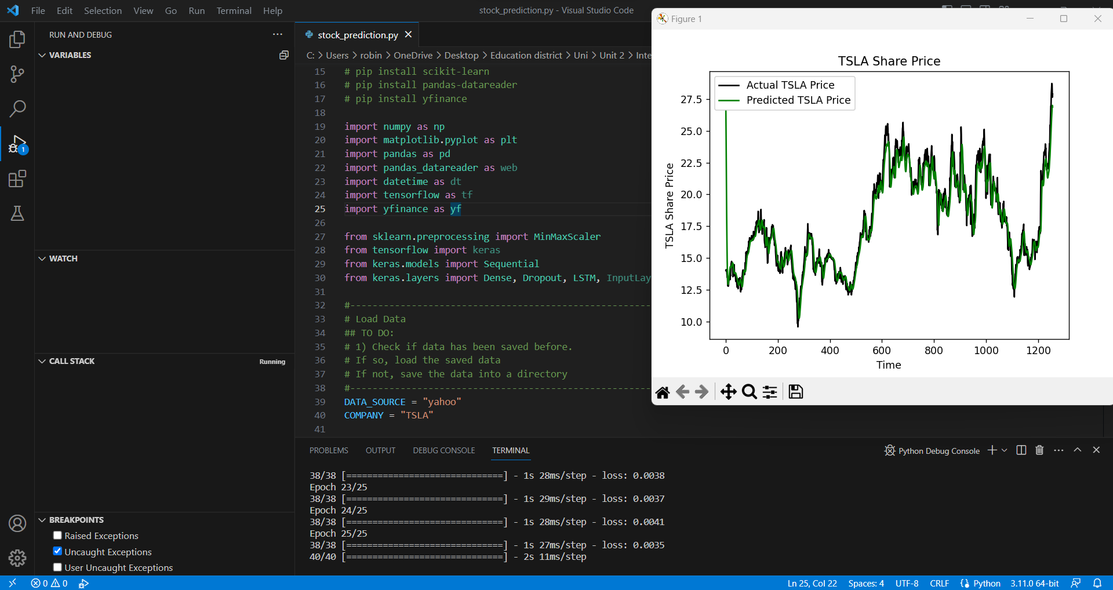

Figure 01

I tried following the tutorial to make my own version, however this did not work as it used pandas_datareader which apparently no longer works. I am guessing the v0.1 file is an adapted the code from the tutorial, however with a pandas_datareader replacement.

Setting up P1 was more difficult. I sucessfully installed the requirements and the program ran, however it couldn’t find a file that was needed. I discovered it needed a results file and for some reason the program doesn’t make a new results file. I wasn’t sure if I needed to make one, but I found an old results file in the folder and renamed it to be the file it was expecting and it works as can be seen in Figure 02

Figure 02

**V0.1 Explanation**

From what I understand of the v0.1 program, it works by running a machine learning system using the tensorflow library. It first downloads the stock information from yahoo, and then it trains the system to predict what the next day of stock information would be based on data. It does this 25 times (epochs), each with 32 days worth of data (batch_size). It predicts the next day’s data in each batch and compares the predicted the data against the real data for the following day. Once this training is completed, it is then used to predict the stock data as shown in figure 01